
A12
Sreenidhi Institute of Science and Technology
(An Autonomous Institution)
Code No: 3AC43
B. TECH. II-Year I-Semester Examinations, December 2015 (Supplementary)
NETWORK ANALYSIS (ECE)

Time: 3 Hours Max. Marks: 70

Note: No additional answer sheets will be provided.

Part - A
Max.Marks:20

Answer all QUESTIONS. EACH QUESTION CARRIES 2 MARKS.
1 |  |  | Compare series and parallel circuits? |  | [2M]
2 |  |  | Define RMS value or effective value of an alternating quantity? |  | [2M]
3 |  |  | Define form factor? |  | [2M]
4 |  |  | Find the value of R_{L} for maximum power transfer?  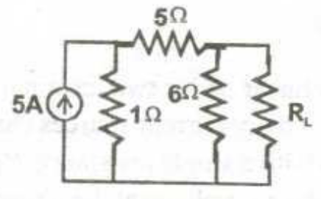 |  | [2M]
5 |  |  | What are Half power frequencies? |  | [2M]
6 |  |  | State the dot rule for coupled circuits? |  | [2M]
7 |  |  | How the RL circuit behaves for the step input? |  | [2M]
8 |  |  | What is the voltage triangle for a RLC series circuit? |  | [2M]
9 |  |  | What is the tuned circuit? |  | [2M]
10 |  |  | Write short notes on band pass filter? |  | [2M]
PART -B
1 |  |  | Find R_{eq} for the network of fig (a) as it is shown (b) with the 5Ω resistor replaced by a short circuit (c) with the 5Ω resistor replaced by an open circuit?  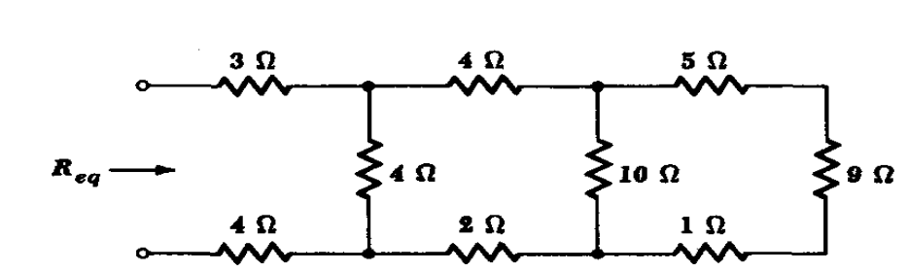 | [10M]
2 |  |  | For the network shown in fig below write a tie set schedule and then find all branch currents and voltages?  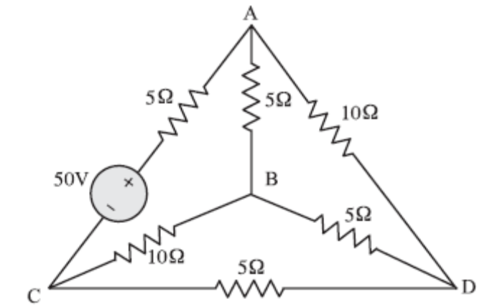 | [10M]
3 | a) |  | Using nodal analysis find v₁ and v₂ in the circuit of fig shown below?  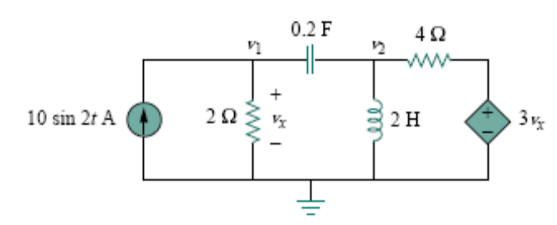 | [6M]
 | b) |  | A series connected circuit has R = 4Ω and L = 25mH  (i) calculate the value of C that will produce a quality factor of 50  (ii) find w₁, w₂ and B? | [4M]
4 | a) |  | Using the superposition theorem, find v₀ in the circuit in fig shown below?  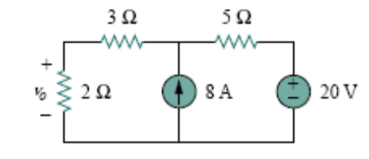 | [5M]
 | b) |  | Find the Thevenins equivalent circuit of the circuit in figure below to the left of terminals a-b?  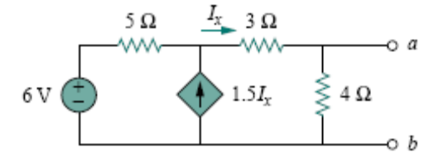 | [5M]
5 | a) |  | Obtain the Y parameters for the T network shown in figure below  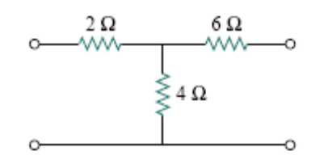 | [5M]
 | b) |  | Find [Z] and [g] of a two port network if  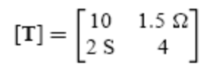 | [5M]
6 | a |  | Find i(t) in the circuit in figure below for t > 0 . Assume that the switch has been closed for a long time?  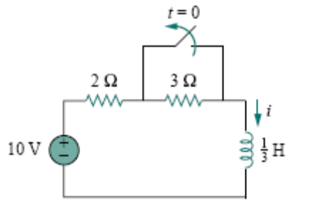 | [5M]
 | b |  | The response of a series RLC circuit is given by  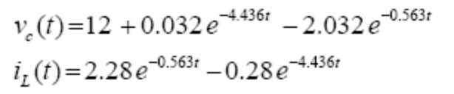  Where v_{c}(t) and i_{L}(t) are capacitor voltage and inductor current respectively. Determine the values of R, L and C of the series circuit? | [5M]
7 | a |  | Obtain the equivalent resistance R_{ab} for the circuit in figure below  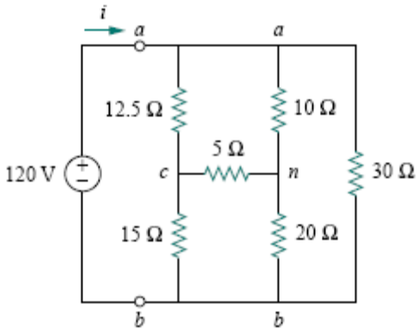 | [5M]
 | b |  | Two coupled coils have self inductances L₁ = 10 x 10⁻³ H and L₂ = 20 x 10⁻³ H. The coefficient of coupling being 0.75 in the air, find voltage in the second coil and the flux of first coil provided the second coil has 500 turns and the current is given by i₁ = 2 sin 314t A? | [5M]
8 | a |  | Design a constant K – high pass filter, having f_{c} = 4KHz and design impedance R₀ = 600 Ω (∏ section) | [5M]
 | b |  | Determine the value of R_{L} in the figure below that will draw the maximum power from the rest of the circuit. Calculate the maximum power?  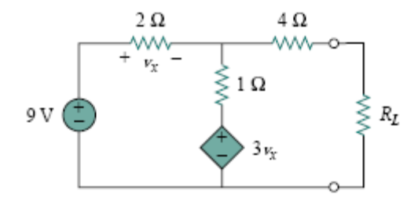 | [5M]

--oo—oo--

